Test Case: tc001_SPX_Dev5_Crear_Solicitud_Articulo_Almacen
Step 1 - Enter username and password and click to button Enter : Credentials Entered
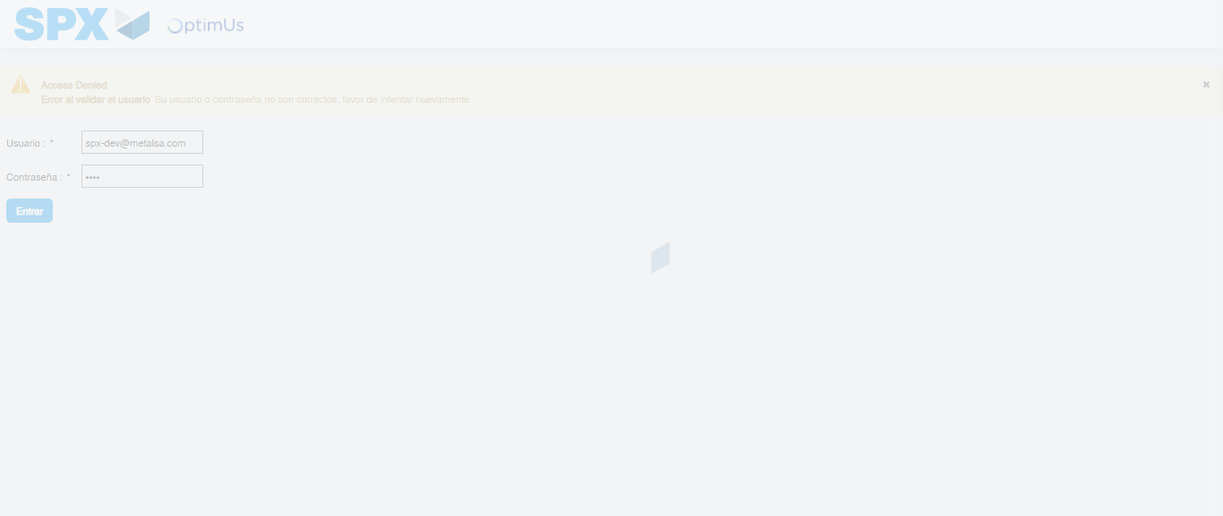Image file-name: QC_Testing-tc001_SPX_Dev5_Crear_Solicitud_Articulo_Almacen-1787856731610

Step 2 - Select to UEN and Access to Request for a New Inventory Item : UEN Correctly selected and Correct access
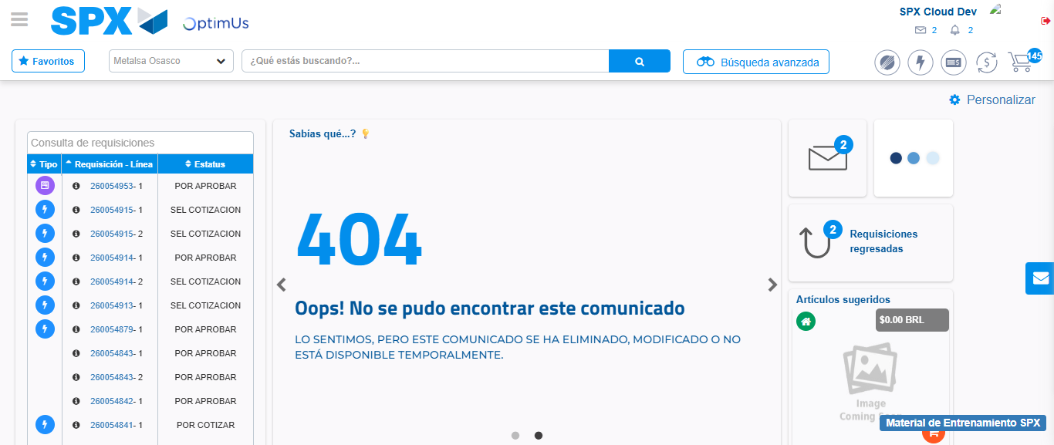Image file-name: QC_Testing-tc001_SPX_Dev5_Crear_Solicitud_Articulo_Almacen-1787856769081

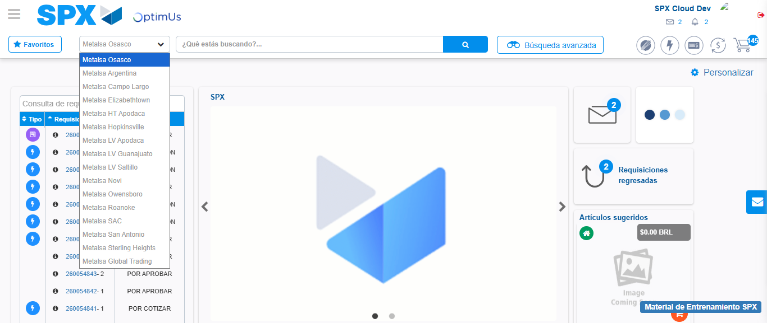Image file-name: QC_Testing-tc001_SPX_Dev5_Crear_Solicitud_Articulo_Almacen-1787856769873

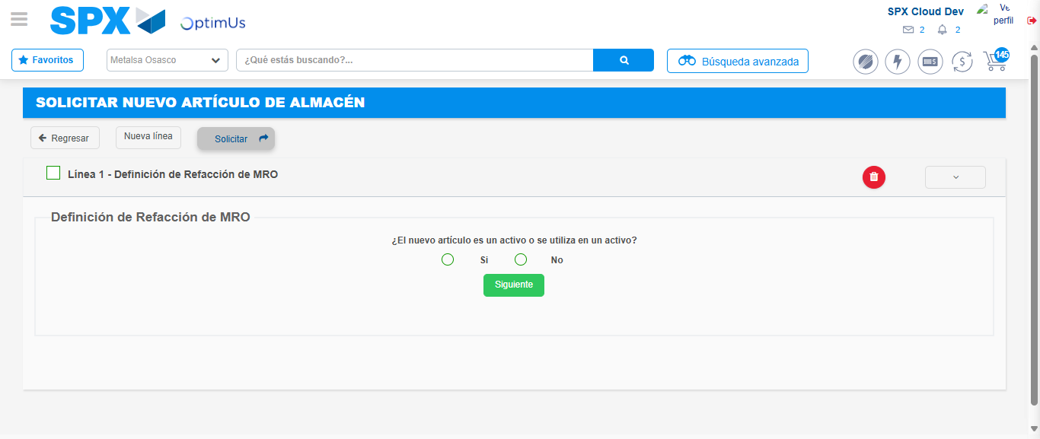Image file-name: QC_Testing-tc001_SPX_Dev5_Crear_Solicitud_Articulo_Almacen-1787856780609

Step 3 - Select options first section : Options seleted correctly
Image file-name: QC_Testing-tc001_SPX_Dev5_Crear_Solicitud_Articulo_Almacen-1787856780939

Image file-name: QC_Testing-tc001_SPX_Dev5_Crear_Solicitud_Articulo_Almacen-1787856781178

Step 4 - Select options section location and position: Options seleted correctly
Image file-name: QC_Testing-tc001_SPX_Dev5_Crear_Solicitud_Articulo_Almacen-1787856780939

Image file-name: QC_Testing-tc001_SPX_Dev5_Crear_Solicitud_Articulo_Almacen-1787856781178

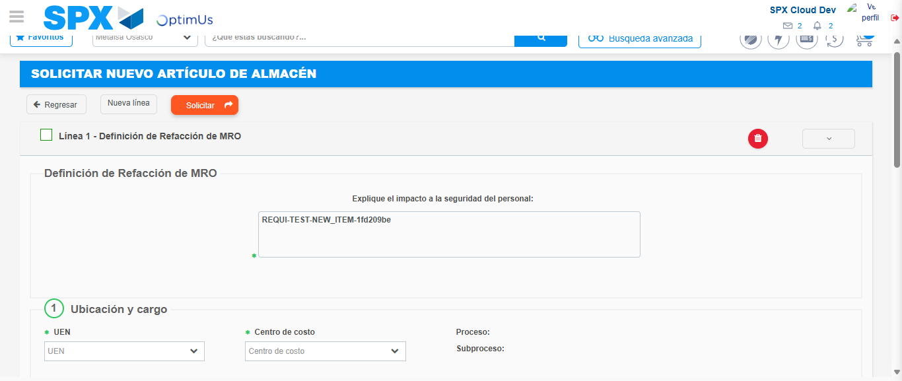Image file-name: QC_Testing-tc001_SPX_Dev5_Crear_Solicitud_Articulo_Almacen-1787856788001

Step 7 - Return to Main Page SPX : Return to Main Page SPX
Image file-name: QC_Testing-tc001_SPX_Dev5_Crear_Solicitud_Articulo_Almacen-1787856769081

Image file-name: QC_Testing-tc001_SPX_Dev5_Crear_Solicitud_Articulo_Almacen-1787856769873

Image file-name: QC_Testing-tc001_SPX_Dev5_Crear_Solicitud_Articulo_Almacen-1787856780609

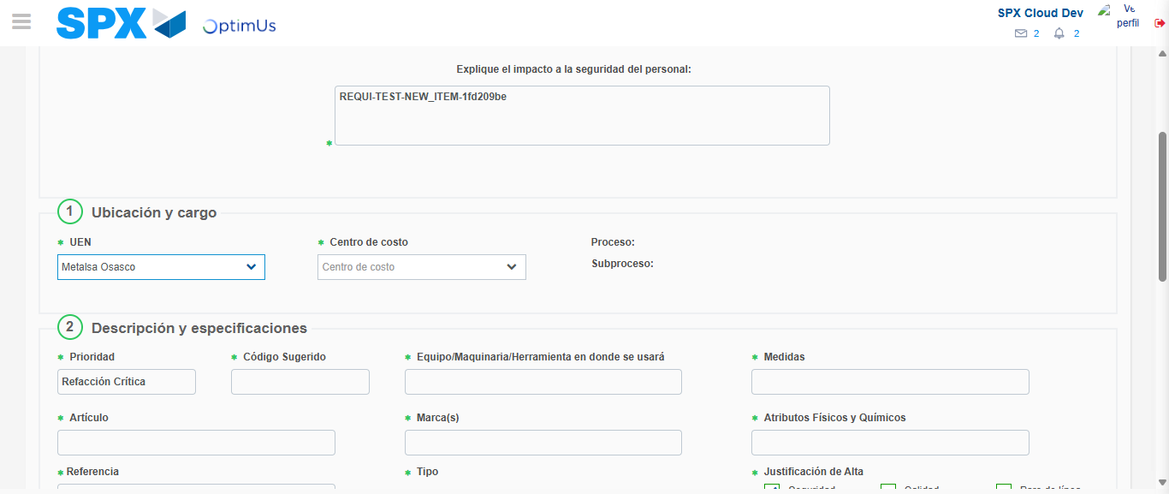Image file-name: QC_Testing-tc001_SPX_Dev5_Crear_Solicitud_Articulo_Almacen-1787856791422

Image file-name: QC_Testing-tc001_SPX_Dev5_Crear_Solicitud_Articulo_Almacen-1787856791668

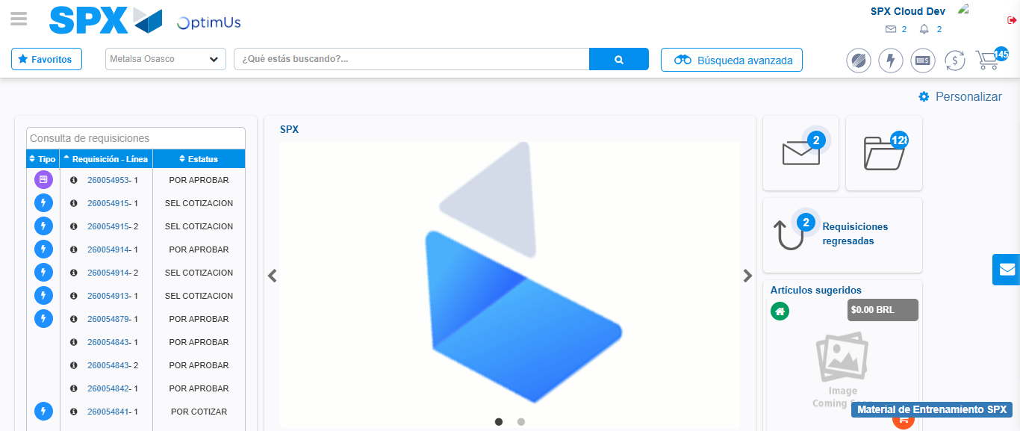Image file-name: QC_Testing-tc001_SPX_Dev5_Crear_Solicitud_Articulo_Almacen-1787856813292

Step 8 - Log Out : Log Out SPX
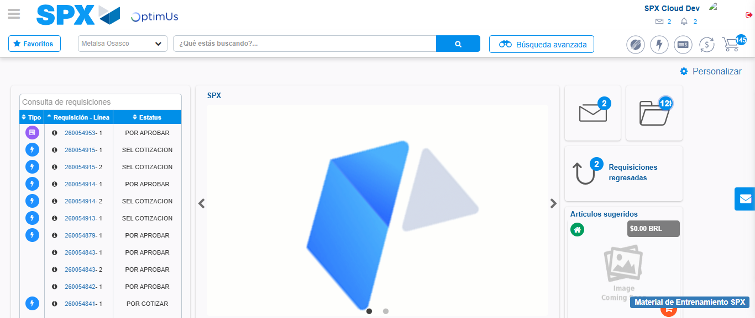Image file-name: QC_Testing-tc001_SPX_Dev5_Crear_Solicitud_Articulo_Almacen-1787856813705

